In response to more frequent and extreme flooding events impacting communities along the Brandywine Creek in both Pennsylvania and Delaware, the Brandywine Conservancy announced the launch of the Brandywine Flood Study in August 2023—nearly two years after Hurricane Ida produced historic flooding that devastated the region.

Conducted in partnership with the Chester County Water Resources Authority (CCWRA) and the University of Delaware Water Resources Center (UDWRC), the flood study is a coordinated effort to better understand where and why flooding occurs and identify the best approaches to protect our communities from future severe flooding events.

Encompassing the mainstem of the Brandywine Creek and key tributaries in Chester and Delaware Counties in Pennsylvania and traveling downstream to impacted areas over the Delaware state line, the flood study aims to identify options for reducing flood impacts to improve public safety and lessen property damage.

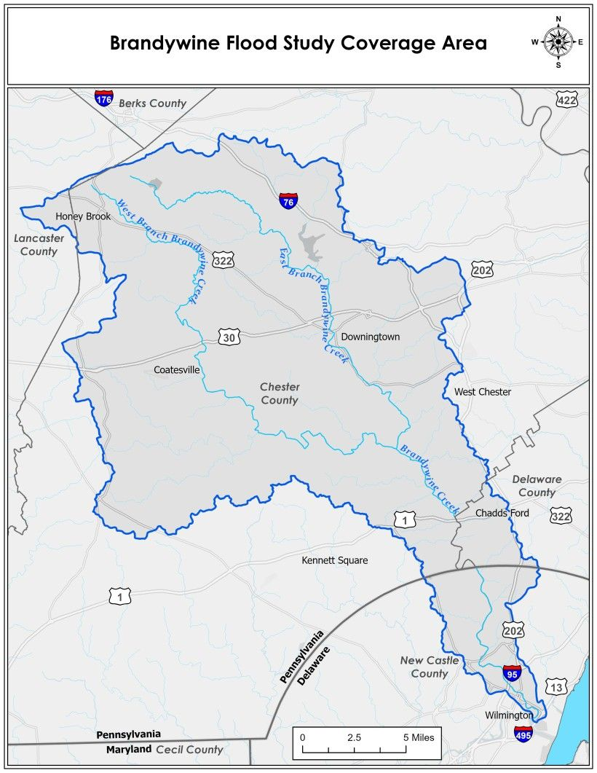
The study is funded through grants from FEMA, PEMA, Chester County Government and Delaware County Council, and is slated to be completed by summer 2024. A series of public meetings are being held at pivotal stages throughout the process to engage with impacted residents and to gather feedback.

The study will also include Stroud Water Research Center, West Chester University, and other technical experts as key partners. Once the study is complete, the team is committed to working with impacted communities, elected officials, key funders, and government agencies to implement the study’s recommendations so that the watershed and its residents in both Pennsylvania and Delaware are better prepared, protected, and equipped to rebound from future severe flooding events.

For more information about the Brandywine Flood Study—including progress updates, notifications about upcoming public meetings, and to join our email list—please visit www.brandywine.org/flood-study. You can also email the team directly with any questions at floodstudy@brandywine.org.

