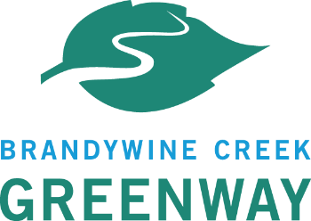
Brandywine Creek Greenway Mini-Grant Program
2024-2025 Mini Grant Application Review Process

Application Deadline: May 13, 2024
- Brandywine Conservancy does a final review of applications for completeness and requests any additional materials from applicants by May 22, 2024.

Applications and Scoring Forms to Reviewers: on or before May 24, 2024
- Applications will be e-mailed along with scoring forms to all reviewers. Depending on the total amount of applications, reviewers will be asked to review some or all of the applications. A reviewer must be recused from all application review if a potential conflict of interest is found to exist.
- Review Committee has until June 21, 2024 to submit scoring forms via e-mail to the Mini Grant Program Administrator via email at ehadley@brandywine.org.

Brandywine Conservancy Final Review and Communication to DCNR: June 21, 2024
- Brandywine Conservancy completes an internal review and averages the scores submitted by the Review Committee and prepares a list of selected projects for Bureau Manager Approval.

Notification to All Applicants of Application Funding: June 28, 2024

For reference-Spring 2024 Grant Schedule:
- Grant Round Opens: April 15, 2024
- Application Deadline: May 13, 2024 by 5 p.m.
- Grant Awards Announced: July 12, 2024
- Contracts Executed: August 15, 2024
- Projects Begin: September 2024
- Projects End: October 2025
- Final Site Inspections by Mini Grant Local Project Coordinator: October 2025
- Final Payments: Upon project completion, satisfactory final site inspection and DCNR approval

