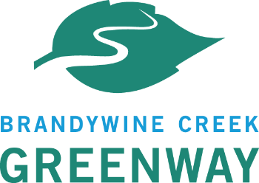
Brandywine Creek Greenway Mini-Grant Program
2024-2025 Mini Grant Rolling Application Review Process
Rolling Application Period: August 1st 2024- August 1st 2025
- Brandywine Conservancy does a final review of applications for completeness and requests any additional materials from applicants within 30 days of submission.

Applications and Scoring Forms to Reviewers: 28th-30th of each month
- Applications will be e-mailed along with scoring forms to all reviewers. Depending on the total amount of applications, reviewers will be asked to review some or all of the applications. A reviewer must be recused from all application review if a potential conflict of interest is found to exist.
- Review Committee has 3 weeks upon receiving the monthly applications to submit scoring forms via e-mail to the Mini Grant Program Administrator via email at ehadley@brandywine.org.

Brandywine Conservancy Final Review and Communication to DCNR:
within 1 week from receiving scores from Review Committee
- Brandywine Conservancy completes an internal review and averages the scores submitted by the Review Committee and prepares a list of selected projects for Bureau Manager Approval.

Notification to All Applicants of Application Funding:
within 1 week after receiving DCNR Bureau Manager Approval

For reference- 2024-2025 Grant Schedule:
- Grant Round Opens: August 1, 2024
- Application Deadline: August 1, 2025 by 5 p.m.
- Grant Awards Announced: within 4-8 weeks of application
- Contracts Executed: within 8 weeks of application
- Projects Begin: September 2024
- Projects End: September 2025
- Final Site Inspections by Mini Grant Local Project Coordinator: October 1, 2025
- Final Payments: Upon project completion, satisfactory final site inspection and DCNR approval

