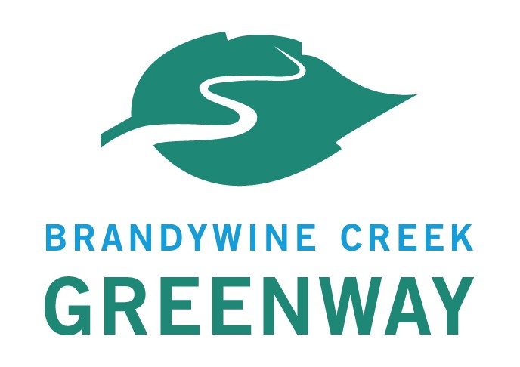
Brandywine Creek Greenway
2020-2021 Mini Grant Program
Instructions and Guidelines

Content Includes:

- • General Information
- • Eligibility
- • Brandywine Creek Greenway Goals & Objectives
- • Application Submission Process
- • Application Review Process

General Information
The Brandywine Creek Greenway Mini Grant Program is a reimbursement funding program, which is supported by the Pennsylvania Department of Conservation and Natural Resources (DCNR). The Brandywine Creek Greenway Mini Grant Program is administered by the Brandywine Conservancy, the coordinator of the Brandywine Creek Greenway. The Brandywine Conservancy was awarded $40,000 from the DCNR Community Conservation Partnership Program Environmental Stewardship Fund administered by the Bureau of Recreation and Conservation (BRC) for the 2020-2021 Brandywine Creek Greenway Mini Grant Program.

This program will provide mini grants of $2,000 to $10,000 to projects that support and advance the goals and objectives of the Brandywine Creek Greenway. Mini-grants may not be used to fulfill match requirements for any other DCNR-funded grant programs. All projects, related costs and funding must conform to the guidelines of the PA DCNR Community Conservation Partnership Program: http://www.docs.dcnr.pa.gov/cs/groups/public/documents/document/dcnr_017036.pdf

Mini-Grants require a 1:1 local match in the form of cash and/or eligible non-cash (in-kind) services.
- Cash Match - No portion of the cash match can originate from DCNR funding.
- In-kind Match - the value of municipal labor and/or professional services is equal to the hourly billable rate multiplied by the number of hours performing that service or job. The value of volunteer in-kind will be valued at the current Independent Sector Volunteer Rate for Pennsylvania at the time the work was performed. Please visit http://www.independentsector.org/volunteer_time for current volunteer value.
- Applicants must provide proof of match commitment.
- This grant program cannot offer waivers of retroactivity for applications for any reason.

The Brandywine Creek Greenway Mini Grant Program is a reimbursement funding program. Costs should be described in the budget and will be paid only to the extent that they are incurred by the grantee in performance of the project’s scope of work. Awardees can receive a reimbursement once throughout the grant process for a total of 90% of the grant award and will receive the remaining 10% after a successful final site inspection. Awardees must submit a mid-grant progress report and final progress report. All Project deliverables must also be submitted at the close-out of the grant.

Important Dates:
- Grant Round Opens: July 31, 2020
- Application Deadline: September 15, 2020
- Grant Awards Announced: November 29, 2020
- Contracts executed: December 31, 2020
- Projects Begin: January 1, 2021
- Projects Completed: December 31, 2021
- Final Site Inspections by Mini Grant Local Project Coordinator: January- April 2022
- Final Payments: Upon project completion, satisfactory final site inspection, and DCNR approval

Questions:
For questions about this program, please contact Meredith Mayer at Brandywine Conservancy by telephone at 610-388-8351 or via e-mail: mmayer@brandywine.org.

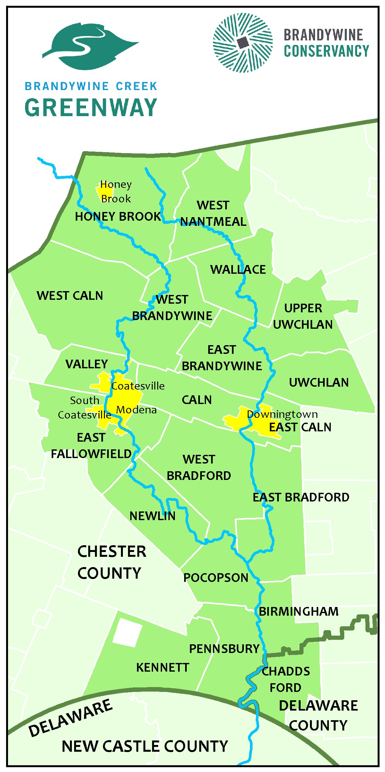
Eligibility
Who is eligible?
Eligible applicants include Pennsylvania non-profit organizations with tax-exempt status 501(c)(3), municipalities, counties, and some educational institutions. Non-profit organizations must submit proof of non-profit status and be registered with the PA Department of State Bureau of Charitable Organizations.

What kind of project is eligible?
Eligible projects should advance the Strategic Action Plan of the Brandywine Creek Greenway and may also reference county level planning documents such as Chester County’s Landscapes3 or Delaware County’s Open Space, Recreation, and Greenway Plan or municipal level planning documents such as a Comprehensive Plan, Open Space Plan, or Park Master Plan.

All projects must be located within the Pennsylvania portion of the Brandywine Creek Greenway which is depicted in green on the map on this page and includes Birmingham Township, Caln Township, Chadds Ford Township, the City of Coatesville, Downingtown Borough, East Bradford Township, East Brandywine Township, East Caln Township, East Fallowfield Township, Honey Brook Township, Honey Brook Borough, Kennett Township, Modena Borough, Newlin Township, Pennsbury Township, Pocopson Township, South Coatesville Borough, Upper Uwchlan Township, Uwchlan Township, Valley Township, Wallace Township, West Bradford Township, West Brandywine Township, West Caln Township, and West Nantmeal Township.

Brandywine Creek Greenway Strategic Action Plan Overall Goals and Objectives
The Brandywine Creek Greenway Strategic Action Plan has eight overall goals and objectives that are applicable to all Greenway municipalities, county agencies, state agencies, non-profit groups, and other stakeholders. The second part of the Strategic Action Plan is a Project Portfolio that identifies recommended projects that are unique to each municipality/agency. Municipalities are encouraged to reference their own Project Portfolio in addition to one to two of the overall goals and objectives that are most applicable to the proposed project. The overall goals and objectives are listed below. Individual project portfolios can be found here: https://www.brandywine.org/sites/default/files/media/Strategic%20Action%20Plan%20Part%202.pdf or here https://www.brandywine.org/conservancy/greenway/publications.

GOAL 1 TRANSPORTATION
To provide safe transportation alternatives for walking, bicycling, and equestrian users.
Objective 1 Preserve and maintain existing multi-use trails and develop connecting links between Greenway hubs and major destinations.
Objective 2 Enhance the safety along existing bike routes.
Objective 3 Provide safe transportation for existing horse-drawn carriage routes, especially in agricultural areas.

GOAL 2 CONSERVATION
To protect and improve vital natural resources within the Brandywine watershed.
Objective 1 Maintain, enhance, and restore habitat corridors.
Objective 2 Protect existing riparian corridors.
Objective 3 Restore forest cover along riparian buffers.
Objective 4 Preserve existing woodlands.
Objective 5 Preserve agricultural lands and soils.
Objective 6 Preserve and enhance water quality.
Objective 7 Protect sensitive plant and animal habitats and important bird areas from recreational overuse.

GOAL 3 RECREATION
To promote and enhance the recreational use of municipal, county, and state-owned recreational open space.
Objective 1 Create an interconnected network of pedestrian and bicycle paths that connect neighborhoods to public recreational lands and schools.
Objective 2 Protect and expand the equestrian trail network to connect with Marsh Creek State Park, Honey Brook Borough, Elverson Borough, Welsh Mountain Trail, Struble Trail, and the Horseshoe Trail.
Objective 3 Ensure that residents of all ages and abilities have access, where feasible, to recreational facilities such as parks and trails.
Objective 4 Improve public access to the Brandywine Creek.

GOAL 4 FLOOD CONTROL
To mitigate flooding in flood-prone areas.
Objective 1 Reduce impervious surfaces and increase infiltration in developed headwater areas.
Objective 2 Increase percentage of tree cover to reduce runoff and maximize evapotranspiration.
Objective 3 Observe recommendations in the Act 167 Stormwater Management Plan for Chester County, as appropriate.

GOAL 5 CULTURE
To preserve nationally and municipally-designated historic resources and their surrounding landscapes.
Objective 1 Protect and promote the historic structures, districts, trails, and cultural features of the Brandywine Valley.
Objective 2 Link historic features.

GOAL 6 AESTHETICS
To protect state and municipally-designated scenic resources and buffer scenic resources from new development.
Objective 1 Preserve the scenic integrity of the Lower Brandywine PA Scenic River Corridor.
Objective 2 Protect and preserve the scenic resources along the Brandywine Valley Scenic Byway.
Objective 3 Designate new scenic roads where deemed appropriate.

GOAL 7 EDUCATION
To foster education of the Brandywine Creek and its watershed.
Objective 1 Raise awareness of the importance of conservation and best land management practices.
Objective 2 Educate residents regarding the natural, recreational, and cultural features within the Greenway corridor.
Objective 3 Raise awareness of the regional context and local identity of the Greenway with area stakeholders and groups such as the Delaware Valley Regional Planning Commission (DVRPC), Chester County Planning Commission (CCPC), Delaware County Planning Department (DCPD), and the PA Department of Conservation and Natural Resources (DCNR).

GOAL 8 ECONOMIC PROSPERITY
To foster economic activity in urbanized areas.
Objective 1 Increase the number of visitors to existing recreational facilities within the Greenway.
Objective 2 Implement regional open space and transportation initiatives such as the Central Chester County Bicycle and Pedestrian Circulation Plan, the Struble Trail, and the Chester Valley Trail.
Objective 3 Promote the city and boroughs as trail towns that offer a range of goods and services for Greenway visitors.

Application Submission

Format:
- The application can be downloaded from the Brandywine Creek Greenway website: https://www.brandywine.org/conservancy/greenway
- Application narratives should be clear and concise.
- The application can be submitted electronically or by mail.
- All required supporting documents should be attached as either WORD or PDF documents and should be identified as your application’s documents.

Deadline for Submission:
- Email application submissions:
- Electronic applications must be received by 4:00 p.m. on September 15, 2020.
- Subject Line should read “2020 Mini Grant Submission.”
- Email applications to Meredith Mayer at mmayer@brandywine.org.
- All applicants will receive an email confirmation of receipt of application. If you do not receive this email – applicants must contact us by phone at 610-388-3851 to ensure that your application was received and will be considered.
- E-mailed applications received after this date and time will not be considered.

- Mail, ship, or hand delivery:
- If you are unable to submit the application electronically, the completed application and required documents may be mailed, shipped, or hand delivered in enough time for the application to be received by Brandywine Conservancy (P.O. Box 141, Chadds Ford, PA 19317) by 4:00 p.m. on September 15, 2020.
- Mailed, shipped, or hand delivered applications received after this date and time will not be considered.

Applicant Responsibilities:
- Identify projects that support the Brandywine Creek Greenway’s Strategic Action Plan.
- Secure local match at a minimum ratio of 1:1 (can be cash and/or in-kind services).
- Provide letters of commitment from partners providing local match; letters should describe the type of program assistance, match amount and how that partner is contributing to the success of the project.
- Demonstrate the ability to complete project on time and within budget. (Awarded projects must be completed in a 12-month time frame)
- Submit application on time – by 4:00 pm on September 15, 2020.
- For non-profit applicants: provide current proof of IRS 501(c)3 non-profit status and registration with the PA Bureau of Charitable Organizations.
- Grantees are responsible for following the competitive bidding requirements that apply to their organizations. These vary based on whether the organization is a municipality or a non-profit. Grantees not familiar with the applicable bidding requirements are strongly advised to consult with their solicitor/ attorney.

Application Review:
Applications will be ranked by a review committee composed of a DCNR Regional Adviser, a representative of Brandywine Conservancy, a Chester County representative, and a Delaware County Representative.

Applicants will be ranked based on how well the project:
- Supports and advances the goals and objectives of the Brandywine Creek Greenway Strategic Action Plan
- Can be completed in a 12-month timeframe
- Promotes partner collaboration
- Identifies and secures required match
- Develops a realistic budget
- Demonstrates that project will have measurable outcomes and be successful
- Incorporates green and sustainable management practices. (Examples include use of native plants; non-structural stormwater best management practices (rain gardens, vegetated swales, minimize disturbance, minimize impervious coverage, maximize infiltration close to source); prioritizing the use of recycled, locally made, or re-purposed materials; and trails built with materials that are porous where appropriate.)

The review committee reserves the right to request additional proposal information if they feel such information is crucial to the ranking process.

Scoring Matrix

Brandywine Creek Greenway (BCG) 2020 Mini‐Grant Program Scoring Form
Applicant Name: |  | Reviewer Name:
REVIEW and SCORING CRITERION |  |  | POINTS
Part 1: APPLICANT INFO (NOT SCORED)
Part 2: PROJECT DETAILS: DESCRIPTION, GREEN PRACTICES, SCOPE OF WORK, TIMELINE, PARTNERS, INTEGRATION (Total Section 3-25 points)
2A., 2B., 2C., 2D. Project Description, Green Practices, Scope of Work, and Timeline: Does project have the capacity and capability to be successful and to complete all described activities within the grant timeline? Are green practices incorporated? (15 points)
1 to 5 | 6 to 10 | 11 to 15
Project is not well-planned, and no green practices incorporated | Projects is adequate, can be successful, and green practices incorporated | Project is well planned and will be successful, green practices are well planned and incorporated
2E. Partners: Does project involve collaboration with other partners: municipalities, non‐profits, watershed groups, agencies, businesses and/or health organizations, etc.? (5 points)
1 | 3 | 5
Project has no/few partners or collaborations established | Project has some involvement of partners but roles not well defined and evidence of commitment is weak | Project has strong, committed partners and collaborations with well-defined roles and involvement
2F. Integration: Is project consistent with state and/or local planning priorities? (5 points)
1 | 3 | 5
No/little evidence of integration with BCG, local, county or state plan/assessment | Integration with BCG, local, county or state plan/assessment exists but not well developed, documented or demonstrated | Integration with BCG local, county or state plans/assessment is well developed, documented and demonstrated

Part 3: GOALS, OUTCOMES and ACTIVITIES (Total Section 1‐15 Points)
3A. Goals, Outcomes and Activities: Do project goals, outcomes and activities align with/advance the goals of the Brandywine Creek Greenway? (15 points)
1 to 5 | 6 to 10 | 11 to 15
Project does not address/advance the goals of the Brandywine Creek Greenway | Project addresses one or more of the goals of the Brandywine Creek Greenway and is adequately explained | Project fulfills and actively advances one or more of the goals of the Brandywine Creek Greenway and is explained thoroughly
Part 4: BUDGET (Total Section 2‐10 Points)
4A. Proposed Budget (attachment to application): Does budget adequately support goals, costs, and activities of the project? (5 points)
1 | 3 | 5
Budget does not adequately support the project | Budget is adequate | Budget is well developed and adequate to support the project
4B. Local Match: Is local match secured and documented? (5 points)
1 | 3 | 5
Required match not secured or documented | Required match amount adequate and secured | All required and additional match secured and well documented
TOTAL POSSIBLE SCORE=50 |  | TOTAL SCORE=

Additional Notes or Comments:

